*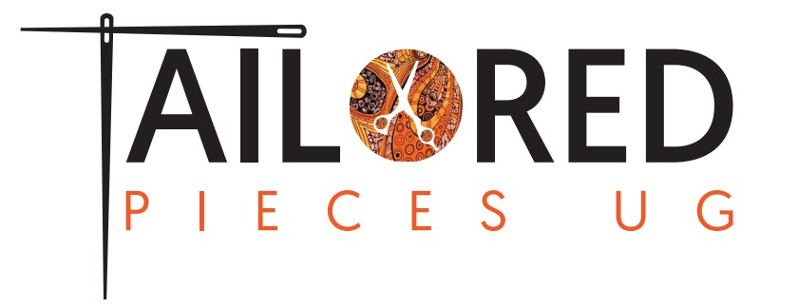*

Terms of Business:

You must submit the body measurements before any custom work can be started.

You should take off everything except your underwear to get an accurate measurement.

Wear no shoes when measuring.

When using a professional seamstress for measuring - you must follow our guide.

Please measure everything 2-3 times to be certain.

Please keep in mind some alterations may be required upon receiving your custom gown. If measurements are slightly off-this will be something you are responsible for.

We will add about an additional inch to chest and waist measurements in order to allow room for some added "ease/breathing room". If you believe your child will go through a growth spurt before receiving your custom gown - it is important that you consider this when submitting measurements. You must submit this information before any custom work can be started.

If you would like for your dress to have an additional train we will add the following:

Note: For dresses with trains, the length of the front of the dress is based on the Hollow to Hem measurement of each standard size. Train length remains the same for all sizes.

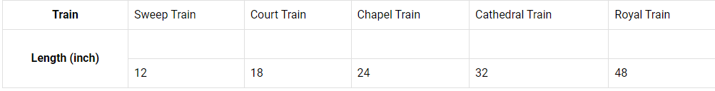

You may opt to use the information below in our measuring charts as well.

Children's basic size guide:

